Barrier Regulation in the Gut
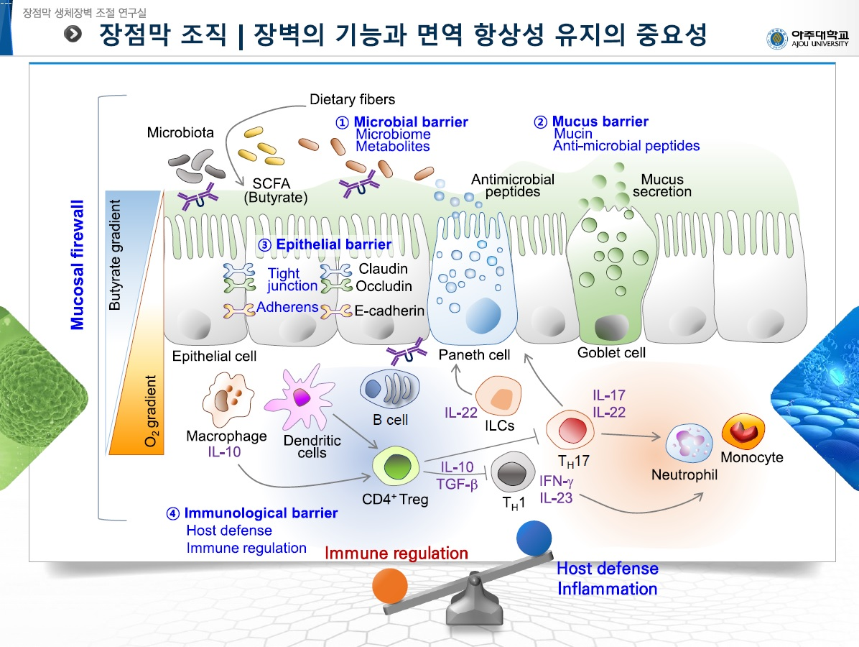
The intestinal mucosa has multi-layered barriers to maintain immunological homeostasis. The intestinal epithelium is a coordinating cross-talk hub and the mucosal immune system established to regulate immune responses against luminal environments. Circulatory antigens transit through the small intestine via the fenestrated capillaries in the lamina propria prior to entering into the draining lymphatics. Gut macrophages can sample and process both circulatory and luminal antigens. Cross-presentation by CX₃CR1⁺ macrophages induced unique subset of CD8⁺ T cells that expressed interleukin-10 (IL-10), IL-13, and IL-9. In addition, CX₃CR1⁺ macrophages directly induced IgA secretion by B cells. The induction of IgA by CX₃CR1⁺ macrophages required BAFF, APRIL and TNF-α and could be enhanced by CD8⁺ T cells through the secretion of IL-9 and IL-13. These data reveal a previously unrecognized cellular circuitry in which CX₃CR1⁺ macrophages, B cells and CD8⁺ T cells coordinate immune regulation and IgA secretion in the small intestine upon peripheral antigen delivery. Intestinal epithelial cells are adapted in mucosal hypoxia and hypoxia-inducible factors (HIF) in these cells can fortify barrier integrity to support mucosal tissue healing. HIF stabilization signaling by CG-598 a novel HIF prolyl hydroxylase inhibitor efficiently and specifically ameliorated intestinal inflammation with limited inflammatory lesions and lesser production of pro-inflammatory cytokines in the experimental murine colitis model. CG-598 treatment fortified barrier function by increasing the expression of mediators associated with barrier function such as intestinal trefoil factor, CD73, E-cadherin, and mucin. CG-598 regulates inflammatory immune tone via the induction of IL-10 and IL-22 from lamina propria CD4⁺ T cells. The effectiveness of CG-598 was comparable to other therapeutics such as TNF-blockers or JAK inhibitors. These results suggest that CG-598 could be a promising therapeutic candidate to treat inflammatory bowel disease.

