Spatial Modifications and Spatial Biology
Hyun-Woo Rhee
Department of Chemistry, Seoul National University, Korea
Proximity labeling can be defined as an enzymatic "in-cell" chemical reaction that catalyzes the proximity-dependent modification of biomolecules in live cells. As this labeling reaction is proximity-dependent due to the short lifetime of reactive species, it can be used to study spatial biology by mapping spatial proteomes, transcriptomes, and spatial cellular networks. In our lab, we have developed a super-resolution proximity labeling technique (SR-PL) and we used it for architecture mapping of metabolic components of mitochondria in live mammalian cells and in mammalian tissues^{[1].} Recently, we recognized parallels between spray-type modifications (e.g., Acetyl Spray, ADPR Spray, SUMO Spray, etc) and proximity labeling techniques, as both involve chemical interactions between electrophilic groups and nucleophilic moieties in close proximity^{[2]}. In this talk, I will explore how spray-type modifications can impact spatial biological components, offering a promising avenue for unraveling the complexities of spatial biology.

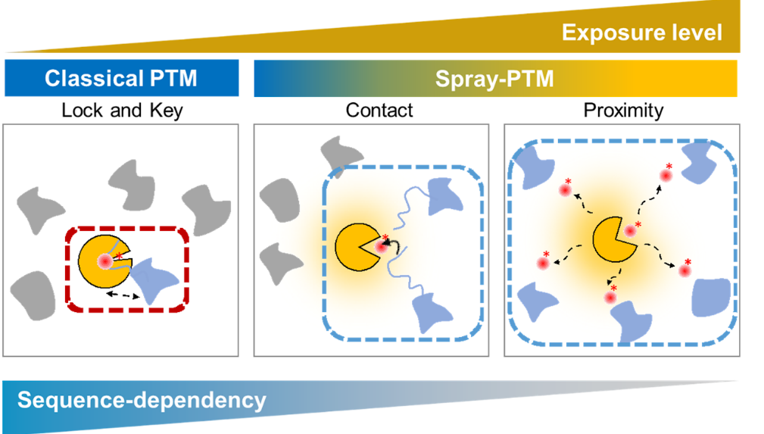

Reference
1. Park I, Kim KE, Kim J, et al. Mitochondrial matrix RTN4IP1/OPA10 is an oxidoreductase for coenzyme Q synthesis. Nat. Chem. Biol. 2024, 20, 221-233.
2. Lee YB, Rhee HW. Spray-type modifications: an emerging paradigm in post-translational modifications. Trends Biochem. Sci. 2024, 49, 208-223.

